**ASSIGNMENT 2**

**PYTHON CODE TO CONTINUOUSLY GET VALUES OF TEMPERATURE AND HUMIDITY AND SET ALARM ON IN CASE OF HIGH TEMPERTAURE**

**CODE**

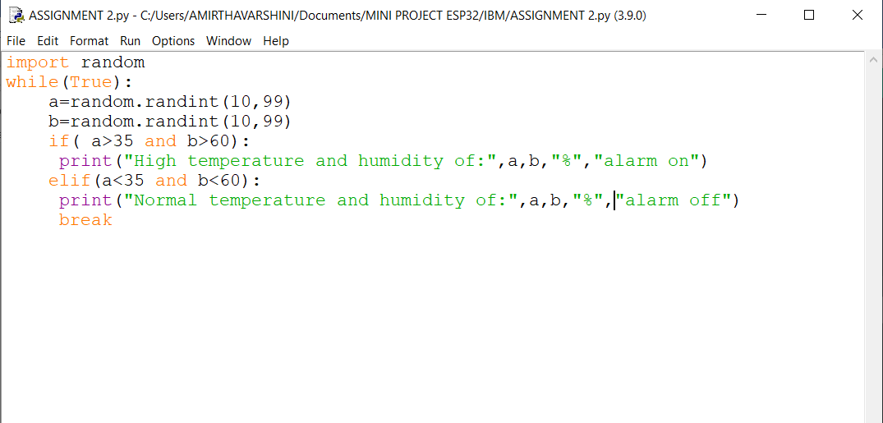

**OUTPUT**

